MOTRR VS ACO

Based solely on my understanding of the MOTRR algorithm from the details you previously provided, here are some potential reasons why MOTRR could be better than a traditional ant colony optimization algorithm for tourism route recommendation:

1. Multi-Objective Optimization: MOTRR is specifically designed as a multi-objective evolutionary algorithm, allowing it to optimize multiple objectives simultaneously, such as travel time, distance, attraction variety, and user preferences. Ant colony algorithms typically focus on single-objective problems like finding the shortest path.
2. Decomposition Approach: MOTRR uses a two-stage decomposition method to break down the multi-objective problem into smaller subproblems, making it easier to optimize different aspects of the route recommendation separately before combining solutions.
3. Pareto Layering: The Pareto layering technique employed by MOTRR helps maintain diversity in the solutions and prevents the algorithm from getting trapped in local optima, a common issue with regular ant colony algorithms.
4. User Preference Integration: MOTRR explicitly considers user preferences and crowdsensing data (like reviews and POI information) in its route construction component, tailoring recommendations to individual tourists' needs more effectively.
5. Distribution and Diversity: The combination of decomposition and Pareto layering in MOTRR aims to address issues like long tails, sharp peaks, and disconnected regions in the Pareto-optimal front, leading to better distribution and diversity of route recommendations compared to regular ant colony approaches.

However, it's important to note that the suitability of an algorithm depends on the specific problem requirements and constraints. Ant colony optimization algorithms may still be preferred in certain scenarios due to factors like simplicity, convergence speed, or problem-specific characteristics.

For the specific case of generating tourism routes, MOTRR could potentially be better than a traditional ant colony optimization algorithm for the following reasons:

1. **Multi-Objective Optimization**: MOTRR is designed to optimize multiple objectives simultaneously, such as minimizing travel time and distance, maximizing attraction variety, and incorporating user preferences. This makes it more suitable for generating well-rounded and personalized tourism routes that balance various factors, which may be challenging for traditional ant colony algorithms that typically focus on a single objective like finding the shortest path.
2. **Integration of User Preferences**: MOTRR explicitly considers user preferences and crowdsensing data (e.g., reviews, ratings) when constructing routes. This allows it to generate routes that are not only efficient in terms of travel time and distance but also align with individual tourists' interests and preferences, enhancing the overall attractiveness and satisfaction of the recommended routes.
3. Diversity of Solutions: The Pareto layering technique used in MOTRR helps maintain diversity in the generated solutions, preventing the algorithm from converging too quickly to a local optimum. This diversity is beneficial in tourism route recommendation, as it allows the algorithm to explore a wider range of potential routes and provide tourists with multiple attractive options to choose from.
4. **Handling Complex Objectives**: Tourism route recommendation often involves optimizing complex objectives that may conflict with each other (e.g., minimizing travel time vs. maximizing attraction variety). MOTRR's multi-objective evolutionary approach and decomposition method are better suited to handle such complex and conflicting objectives compared to traditional ant colony algorithms, which may struggle to find well-balanced solutions.
5. **Scalability**: MOTRR's decomposition approach and layered structure may allow it to scale better to larger problem instances, such as route recommendations for cities or regions with a vast number of attractions and complex travel networks, compared to traditional ant colony algorithms.

However, it's important to note that the actual performance and suitability of MOTRR or any other algorithm depend on various factors, including the specific problem characteristics, dataset size, and computational resources available. A comprehensive empirical evaluation would be necessary to make definitive claims about the superiority of one algorithm over another in a particular tourism route recommendation scenario.

Colaborative filtering

It's a technique commonly used in recommendation systems. The basic idea behind collaborative filtering is to make predictions about the interests of a user by collecting preferences from many users (collaborating) and finding similarities among them.

* User-based collaborative filtering: This method identifies users with similar preferences and recommends items liked by those similar users.
* Item-based collaborative filtering: This method identifies items that are similar to each other based on user ratings and recommends items that are similar to the ones a user has liked in the past

Collaborative filtering can be quite effective in generating recommendations, especially when there is a large amount of user interaction data available. However, it also has its limitations, such as the "cold start" problem (difficulty in providing recommendations for new users or items) and the sparsity of data (when there are very few ratings or interactions for some items)

CF+itenarary (our case just **thal**)

Collaborative filtering can be utilized in itinerary generation by recommending attractions or activities based on the preferences of similar users who have visited the same destination or locations. Here's how you could incorporate collaborative filtering into the itinerary generation process:

* User Preferences Collection: Collect user preferences or historical data on past itineraries and user interactions. This data could include the destinations visited, attractions or activities enjoyed, ratings given, and any additional feedback provided by users.
* Similar User Identification: Use collaborative filtering techniques to identify users who have similar preferences or travel patterns to the current user. This could involve analyzing similarities in historical itineraries, attraction preferences, or any other relevant data.
* Recommendation Generation: Once similar users are identified, generate personalized recommendations for attractions, activities, or locations based on the preferences of those users. This could involve recommending popular attractions, hidden gems, or unique experiences that align with the user's interests and travel style.

Sample implementation

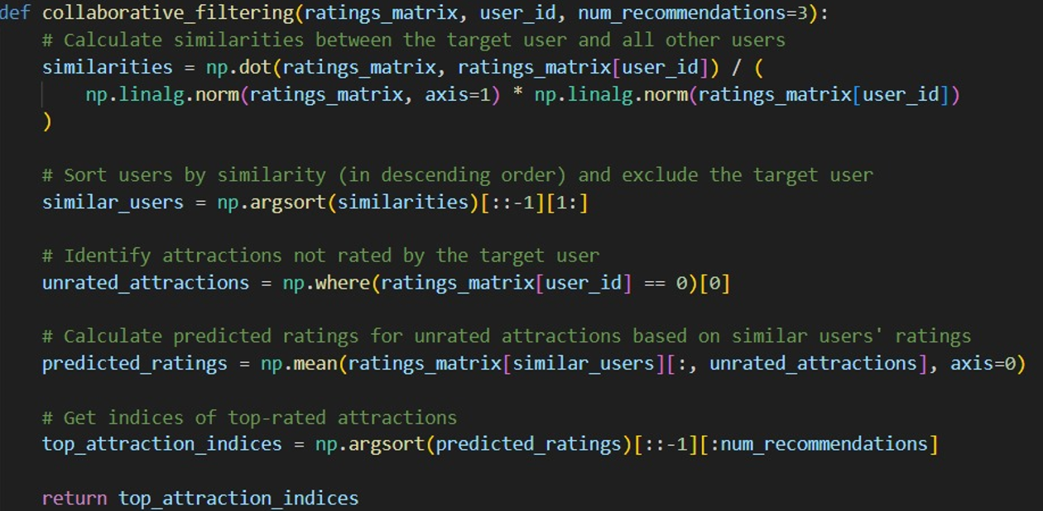

* We have a sample user-item ratings matrix where rows represent users, columns represent attractions, and each cell represents the rating given by a user to an attraction.
* The collaborative_filtering function takes the ratings matrix, target user ID, and the number of recommendations as input.
* It calculates similarities between the target user and all other users, sorts users by similarity, and identifies attractions not rated by the target user.
* Then, it predicts ratings for unrated attractions based on similar users' ratings and returns the indices of the top-rated attractions as recommendations for the target user. •
* Finally, it prints the recommended attractions for the target user.

Explantion

Calculate Similarities:

The function takes three parameters: ratings_matrix, which is a matrix where rows represent users and columns represent attractions, user_id, which is the ID of the target user for whom recommendations are being generated, and num_recommendations, which is the number of recommendations to generate (default is 3).

It calculates the similarities between the target user and all other users in the dataset. This is done using dot product between the ratings matrix and the ratings of the target user, normalized by the product of the norms of each row of the ratings matrix.

Sort Users by Similarity:

The function sorts the users by their similarity to the target user, in descending order. This is done using NumPy's argsort function to get the indices that would sort the similarities array in ascending order, then reversing the order with [::-1], and finally excluding the target user by slicing [1:].

Identify Unrated Attractions:

It identifies attractions that have not been rated by the target user. This is done by finding the indices of attractions where the rating for the target user is 0.

Calculate Predicted Ratings:

Using the ratings given by similar users, the function calculates predicted ratings for the attractions that the target user has not rated. It does this by taking the mean of ratings given by similar users for those attractions.

Get Top-rated Attractions:

Finally, the function retrieves the indices of the top-rated attractions based on the predicted ratings. It sorts the predicted ratings array in descending order using argsort, then reverses the order with [::-1], and selects the first num_recommendations indices.

Return Recommendations:

The function returns the indices of the top-rated attractions as recommendations for the target user.

**Overall**, this function implements a basic collaborative filtering recommendation system that predicts ratings for unrated attractions based on the ratings of similar users and recommends attractions with the highest predicted ratings to the target user.

DATABASE

// Create Priority nodes

FOREACH (priority IN [5, 4, 3, 2, 1] |

CREATE (:Priority {value: priority})

)

Creating Priority Nodes: It creates nodes labeled as Priority, each having a value property. Priorities are represented by integers ranging from 1 to 5. This section of the code uses a FOREACH loop to iterate over an array of priority values and creates a Priority node for each value.

// Load data from CSV

WITH "Load CSV data" AS _ // Dummy alias

LOAD CSV WITH HEADERS FROM 'file:///poi.csv' AS row

FIELDTERMINATOR ','

Loading Data from CSV: It loads data from a CSV file named "poi.csv". The data is expected to have headers, and each row is treated as a separate entity. The FIELDTERMINATOR specifies that fields are separated by commas.

// Create Category nodes and link them to Priority nodes

FOREACH (category IN CASE row.Column2 WHEN '' THEN [] ELSE [coalesce(row.Column2, '')] END |

MERGE (c:Category {name: category})

MERGE (p:Priority {value: 5})

MERGE (p)-[:HAS_CATEGORY]->(c)

)

Creating Category nodes and linking them to Priority nodes: For each row in the CSV file, it checks if the value in row.Column2 is not empty. If it's not empty, it creates a Category node with the name specified in row.Column2 (assuming Column2 contains category names). Then, it merges a Priority node with a value of 5 (regardless of the actual priority value in the CSV file). Finally, it creates a relationship HAS_CATEGORY from the Priority node to the Category node.

// Create Place nodes and link them to Category nodes

FOREACH (row IN CASE WHEN row.Column1 <> 'POI' THEN [row] ELSE [] END |

MERGE (p:Place {name: coalesce(row.Column1, '')})

FOREACH (category IN CASE row.Column2 WHEN '' THEN [] ELSE [coalesce(row.Column2, '')] END |

MERGE (c:Category {name: category})

MERGE (p)-[:HAS_CATEGORY]->(c)

)

creating Place nodes and linking them to Category nodes based on the data from the CSV file.

**Some QUERIES:**

* MATCH (p:Priority {value: 1}) RETURN p
* MATCH (p:Place)-[:HAS_CATEGORY]->(c:Category {name: 'Scenic'})<-[:HAS_CATEGORY]-(pr:Priority{value:5}) RETURN p

Establish connecticity(python)  
from neo4j import GraphDatabase

URI = os.env["URI"]

AUTH = (os.env["Username"], os.env["Password"])

with GraphDatabase.driver(URI, auth=AUTH) as driver:

driver.verify_connectivity()

**DATABASE Structure**

Root Node: (:Priority)

Child Nodes: (:Category) (:Place)

Relationships:

(:Priority)-[:HAS_CATEGORY]->(:Category)

(:Place)-[:HAS_CATEGORY]->(:Category)

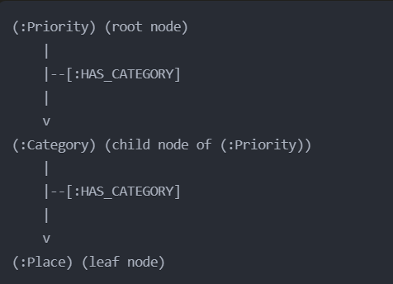

The **root node** in this schema is the (:Priority) node, which represents different priority levels (1 to 5). The code creates five (:Priority) nodes with values from 1 to 5.

The **child** nodes are:

* (:Category) nodes: These represent different categories associated with places. The categories are loaded from a CSV file, and each category is created as a separate (:Category) node.
* (:Place) nodes: These represent the actual places or points of interest (POIs). The names of the places are loaded from the CSV file, and each place is created as a separate (:Place) node.

The **relationships** in the schema are:

* (:Priority)-[:HAS_CATEGORY]->(:Category): This relationship links each (:Priority) node to the associated (:Category) nodes. For example, the (:Priority) node with value 5 is linked to all the (:Category) nodes that represent the highest priority categories.
* (:Place)-[:HAS_CATEGORY]->(:Category): This relationship links each (:Place) node to the associated (:Category) nodes. A place can have multiple categories, and these relationships connect the (:Place) node to all the relevant (:Category) nodes.